Demetrios M. Papazaharias
YOUNG PROFESSIONAL OF THE MONTH
MAY 2016

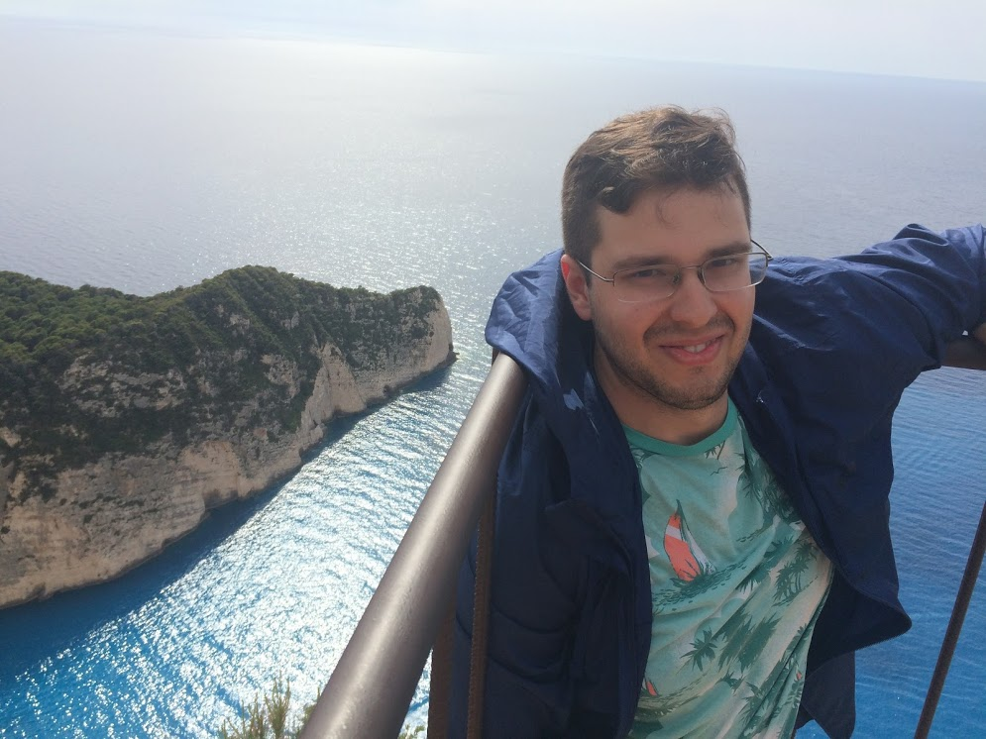

Philo4Thought Hellenic Professional Mentoring Initiative is pleased to present our May 2016 Young Professional of the Month! The goal of our publications is to provide positive, successful role models who will inspire the next generation of young professionals. Preliminary criteria for YPM candidates is that they are actively engaged in an entrepreneurial initiative or have made a successful career for themselves, thereby serving as strong role models to the next generation of young professionals. Candidates are typically of Hellenic origin and part of a humanitarian (educational, sociological, scientific, etc.) or environmentally-conscious field. Given the gradual expansion of our readership, we currently interview candidates who embrace a specific Hellenic philosophy best described in a word… Philotimo (φιλότιμο). The most important qualifications all our candidates share are the spirit and compassion to persevere, and the heart to share their knowledge and experience with others.

This month’s honoree, Demetrios M. Papazaharias, is a dedicated scientific researcher and mentor to many of today’s young professionals through his participation in the National Hellenic Students Association and related initiatives. We are honored to share his story with you today.

THE JOURNEY & “AHA” MOMENT
Demetrios earned his BS in Biology and Society from Cornell University because of his combined interest in science and humanities. “I’m a ‘numbers’ person at heart, but I strongly felt that experience in these other areas was essential for success in any health-related career I would pursue, as we are more than the sum of our organs. Near the end of my undergraduate years, I had my ‘AHA!’ moment when I became interested in public health in the context of infectious disease and weaponized biological agents. At the time (and today too), fears of a global pandemic were escalating and it became clear to me that a good public health system was essential for controlling and preventing massive disease outbreaks. I wanted to learn more about public health and very quickly found myself wanting to incorporate it into my career.”

Based on this interest, he completed an MPH at Drexel University School of Public Health. “I debated between a focus in epidemiology and environmental/occupational health and ultimately chose the latter because it is a field that is understudied and underfunded and had room for advocacy and social justice, two of my most special non-academic interests. In graduate school, I was also able to focus on epidemiology and toxicology and after a series of affirming experiences, I decided on a clinical research career in occupational medicine.”

At present Demetrios is part of a scientifically diverse research team whose interests include chemical and metal exposures, diesel exhaust exposures and health effects, ergonomics, construction-related injuries, among others. “Our mission is to use research to improve clinical practice and ultimately improve health outcomes both in and out of the workplace. It’s a great field with many good, passionate people and I’m glad to use the skills I have developed over the years to help protect workers’ health. After all, we all work and someone needs to study the environments we work in.”

When asked what inspires his work, Demetrios says that it is his innate love for knowledge and a need to delve into the unknown that has always served as the driving force behind his academic and professional pursuits. “By nature, I’ve always been a curious person and have always said that I wanted to be an investigator because I love to follow the clues. Turns out I did become an investigator and the clues I follow are in the data I collect. This, in addition to giving communities a voice they previously didn’t have, makes my job fulfilling. There is never a dull moment in my work.”

PHILOSOPHY
When asked about his philosophy in work and in life Demetrios says, “Professionals have a duty to create (whether it’s knowledge, a service, a product, music, etc.), but what they create needs to be thought about critically. Productivity is important, but creating for the sake of creating doesn’t tell me anything. Figuring out the purpose is much more important because everything follows that.” In life, Demetrios believes that it is very important to be mindful of the world around us and to experience as much as possible. “We’re only here for a finite time. We’re so focused on building for the future that we sometimes forget to take a step back, soak up our surroundings and experience the present.”

As a Greek American, Demetrios explains that his general way of thinking is “inspired by the Greek imagination.” “I marvel at the accomplishments of the Greeks, be it in mathematics, science, literature, thought, music, etc. I also think about how and why the Greeks were able to do so much. Every time I visit Greece, it becomes abundantly clear that the natural beauty of the land, mountains and sea inspires people to think big! When I think about myself and the environmental factors that inspire me, I find that living in New York certainly plays a role. Everything always moves here. Nothing stops– not the people or the energy! I just keep going and I love it.”

MENTORS
When asked who his favorite mentors have been, Demetrios immediately says, “My parents, Michael and Spiridoula Papazaharias, because they always believe in me. Their unconditional love enables me to express myself freely and to bounce ideas off them. Sure, they will be brutally honest, but they will undoubtedly have my best interest at heart at all times. They are excellent role models and have taught me how to be a loving and responsible human being and to embrace our Greek roots.”

CHALLENGES
In scientific research professions funding is always a serious challenge. “Securing funds from the appropriate sources is a craft and requires a high level of grantsmanship. It forces the researcher to critically examine their goals and think about why this research needs to exist. My philosophy certainly helps me overcome this challenge because it helps me anticipate future research needs rather than just focusing on what’s hot today.”

With a job that requires 50-60 hours of focused attention on time-sensitive, deadline-oriented projects as well as additional participation in professional networking activities and volunteer initiatives, time management is another major challenge. “Organization and boundaries are key. I meticulously plan my day and use my phone calendar as well as a physical calendar/notebook where I can organize my priorities and to jot down ideas. I avoid multitasking because any sort of attention splitting results in an inferior product; focusing on one thing at a time is much more efficient and pleasant.”

DOWN-TIME
In his spare time, Demetrios enjoys Greek music (Dimos Moutsis is his favorite), literature and poetry. He also enjoys writing, long walks and a variety of cultural activities (Greek and non-Greek) with friends. “This makes me feel like a citizen of the world. The only thing missing is the world part – I need to travel more.”

Demetrios is also very heavily involved in the Hellenic community since his move to Philadelphia in 2011, where he became a community leader in the Hellenic Student Association of Philadelphia, which hosted the Fall 2012 National Student Association of America Convention. “The event was so successful that we instantly became very well known in the community.” He also served as a Director of the Hellenic University Club of Philadelphia (HUC), which offers the largest sum of scholarship grants to deserving students of Hellenic descent in the Philadelphia area, and was a member of the Executive Board for the Federation of Hellenic American Societies of Philadelphia and Greater Delaware Valley.

At present, Demetrios is the Corresponding Secretary of the HUC and sits on the scholarship committee for the Hellenic University Club of New York. He is also a civilian volunteer of the NYC Medical Reserve Corps, which was set up after 9/11 to help meet public health needs in communities across the country.

“I have learned so much from so many smart people, I consider myself very blessed to be a part of all these organizations.”

WORDS OF WISDOM
The skills Demetrios values most are organization, planning, time management and communication. “These are the skills that are needed to excel, along with hard work and integrity.” The life lesson he values most is one he learned from his parents: “Respect for all, even if you disagree with someone.”

“The possibilities in today’s world are endless, but with those come endless opportunities for distraction. The most important advice I would give to a fellow young professional is to find clarity and purpose and eliminate things in your life that don’t deserve your attention. Learn what works, what doesn’t work. Learn to say ‘no’, which is something younger people – myself included – have trouble saying. Protect your time and make time to take care of yourself.”

Another piece of advice: “Learning does not end once you exit the classroom. Learn a few good skills that will serve you in your career and outside. Not only do they make you more marketable to prospective employers, they help you stay current, may trigger your creativity and will help your mind stay fit for many years to come.”

MENTORING
Demetrios is willing to serve as a Philo4Thought mentor to a younger member of the Hellenic community. Thanks!

READERSHIP
While the primary readership is the young Hellenic professional of New York, we are very pleased that our online exposure has caused our targeted readership to shift beyond this scope! Young professionals of all communities and origins are welcome to contribute comments and questions!

